EC Electronics REACH Statement

As a Contract Electronics Manufacturer (CEM), the EC Electronics Group is committed to carrying out our operations in a manner which supports environmental respect, preservation and improvements.

The Registration, Evaluation, Authorisation and Restriction of Chemicals (REACH) was released as European Union regulation (EC)1907/2006 on 1st June 2007.

According to the regulation, EC Electronics is a contract manufacturer which supplies ‘articles’ to our customers, and does not supply ‘substances’ or ‘preparations’, and our articles do not involve ‘intentional release of substances’. We therefore declare that there is no registration or pre-registration requirement for the products we supply.

EC Electronics has a documented process for ensuring that any Substances of Very High Concern (SVHC) as defined by REACH which are supplied by upstream suppliers that are over the concentration limits specified by the European Chemicals Agency (ECHA) are documented, declared, and the recipient (customer) notified.

The current candidate list of SVHCs and their concentration limits can be found on the ECHA website: https://echa.europa.eu/web/guest/candidate-list-table

EC Electronics is actively engaged in requesting REACH data from suppliers and can conclude that to the best of our knowledge any SVHCs that are supplied to us are not done so in concentrations which exceed current limits. Where this is not the case, our process ensures that this will be communicated with our customers.

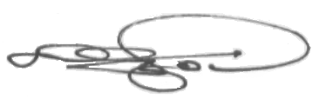

Kevin Osgood
Group Quality Manager

Issue 2, July 2021

